Student’s name | …………………………………………………….…… | Grade | 6
Subject | Computer | Week No. | 5
Lesson Title | Design Thinking | Unit
Worksheet No. ( 5 ) (Answer)

write the correct name of each part.


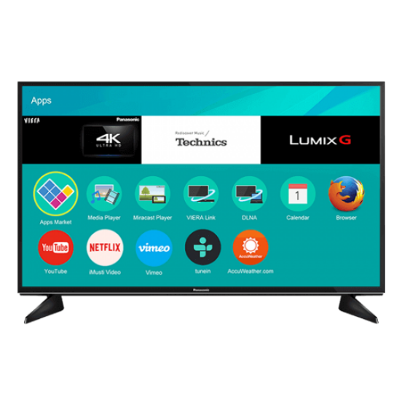

CLI

Calculator

Smart watch
Smart TV
Good Luck

Smart watch
CLI
Calculator
Smart TV

